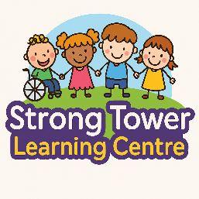

Student Registration Form

Please complete this registration form carefully. All information will be treated as confidential and is required to ensure the safety and wellbeing of your child.

Child’s Full Name
____________________________________________________________

Date of Birth
____________________________________________________________

Year Group
____________________________________________________________

School Name
____________________________________________________________

Home Address
____________________________________________________________

Parent/Guardian Name
____________________________________________________________

Contact Number
____________________________________________________________

Email Address
____________________________________________________________

Next of Kin (Name & Contact)
____________________________________________________________

Authorised Pick-Up Persons (Names & Relationship)
____________________________________________________________

Food Allergies
____________________________________________________________

Medical Conditions / Medication
____________________________________________________________

Special Educational Needs / Additional Support Required
____________________________________________________________

Other Important Information
____________________________________________________________
I confirm that the above information is accurate and complete to the best of my knowledge. I agree to inform Strong Tower Learning Centre of any changes immediately.
Parent/Guardian Signature: ______________________ Date: ___________

Please complete this form and email it back to strongtowerlearningcentre@gmail.com

